MQ-2,-3,-4,-5,-6-,7-,8-9,-135

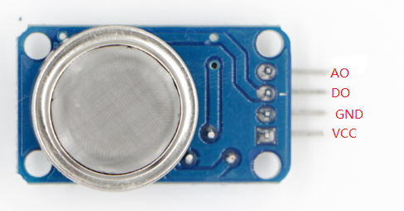

MQ-2 module arduino UNO

VCC --------------------------------5V

GND --------------------------------GND

DO ---------------------------------A0 PIN

1, download the code

2, open com port tool

3, when there is no smoke, com port value is 1017.

When there is smoke, com port value will be 38.

As below:

